7th INTERDISCIPLINARY WORKSHOP ON INTANGIBLES, INTELLECTUAL CAPITAL AND EXTRA-FINANCIAL INFORMATION ON INTANGIBLES AND INTELLECTUAL CAPITAL
Kozminski University, Warsaw, 29-30 September 2011

On 29-30 September 2011, EIASM, in collaboration with the Kozminski University and the University of Ferrara, organized the 7th Interdisciplinary Workshop on Intangibles, Intellectual Capital & Extra-Financial Information in Warsaw, Poland.
(www.eiasm.org/frontoffice/event_announcement.asp?event_id=766)

The goal of this well-established and popular Workshop is to provide a forum where researchers are able to share and discuss the latest ideas and methodologies in the field of Intangibles & Intellectual Capital. By bringing together academics from a wide range of countries, disciplines, and approaches (e.g., organizational theory, accounting, marketing, management, valuation, industrial policy, etc.), this event provides an arena in which to discuss and debate various ways to study the complex world of Intangibles.

This international Workshop, which is held annually, this year consisted of about 60 participants from 20 countries attending what turned out to be an energetic and insightful gathering of established scholars, PhD candidates, post-docs, policy-makers, and practitioners, who participated in the paper presentations, dynamic discussions, and roundtable reflections.

The Inaugural Plenary Session was dedicated to the theme “IC Research and Practice in Eastern European Countries: Some Perspectives”. The speakers were Lidia Adamska (Management Board Member, Warsaw Stock Exchange), Kristof Zorde (Managing Partner, BDO Numerica) and Adam Ringer (Owner and President of Supervisory Board, Paragona Group).

Lidia Adamska, in her speech “Intellectual Capital Reporting at the Warsaw Stock Exchange”, reported on an ongoing Warsaw Stock Exchange project to promote intellectual capital as an additional parameter to be considered for disclosure because it influences the valuation of companies, thereby enhancing the quality of the companies listed, and affecting their level of disclosure.

Kristof Zorde insightfully presented nine different cases of companies in which intellectual capital can explain the differences between the market value and book value. He emphasized, for example, the importance of client relations and brand in “Cyfrowy Polsat”, the fourth-largest digital platform in Europe, and the largest in Central and Eastern Europe.

Adam Ringer closed the Inaugural Plenary Session with his presentation “Exporting Skills and its Carriers – Observations from 10 Years Practice in Providing Healthcare Solutions”, wherein he maintained that the knowledge-transfer through doctors and specialized medical people was a key ingredient for the success of his company, Paragona Group.

The keynote speakers of the Conclusive Plenary Session, devoted to the topic “IC and Intangibles Research as an Interdisciplinary Nexus: Data, Management, Policy & Business Models”, were Prof. Baruch Lev (Stern School of Business, NYU), Prof. Giovanni Schiuma (University of Basilicata and University of Cambridge), Prof. Marco Di Tommaso (University of Ferrara), and Prof. Stefano Zambon (University of Ferrara) [see Photo 1].

Prof. Baruch Lev underlined that the topic of intangible assets is not at all dead, indeed there are signs of a new interest in intangibles and accounting thereof, as shown by the FASB’s recent mandated capitalisation of acquired R&D. He suggested three fields for future research on the basis of these new trends: documenting harms from the non-capitalisation or non-disclosure of intangibles, evidencing relevance to investors of this information and other stakeholders, and comparing IFRS vs. US GAAP.

Photo 1: Prof. Lev (on the right) and Prof. Schiuma (on the left) – speakers at the Conclusive Plenary Session of the Workshop
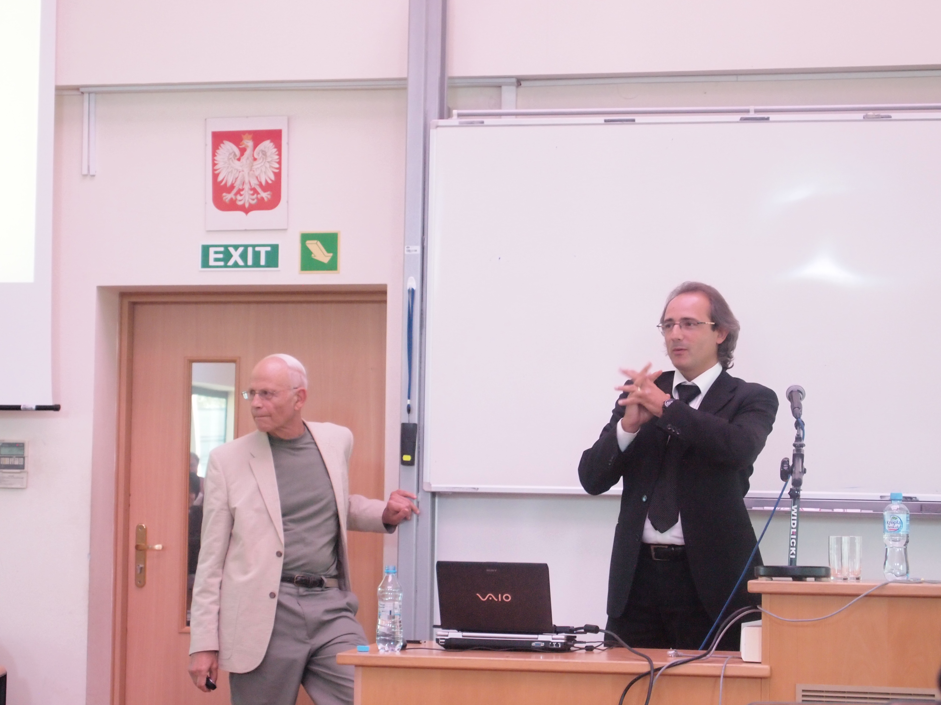

Prof. Giovanni Schiuma presented his speech on “The New Knowledge-based Value Drivers of 21st Century Organizations”, where he provided strong arguments in favour of new drivers for excellence rooted on emotive knowledge and know-feel, as passion, emotions, imagination, intuition, creativity, hope, moral and feeling.

Prof. Marco di Tommaso stressed the policy perspective in the measurement and management of intangibles, encouraging the new possible research paths such as: different units of investigation as institutions, clusters, networks, localities, cities, towns, regions, countries and multicultural approaches, including analyses on various countries such as China, India, Brazil, and Russia, etc.

Prof. Stefano Zambon closed the Conclusive Plenary Session with his speech on “Intangibles and IC between Theory and Practice: An Update”, where he presented the latest initiatives and international developments in the field of intangibles reporting: the IASB’s IFRS Practice Statements on “Management Commentary”, the business model connection, the renewed interest by some governments (France) and international institutions (OECD), the discussion paper by the International Integrated Reporting Committee, the International Valuation Standards Council (IVSC), and the recent activities by the World Intellectual Capital Initiative (WICI) Network.

There were 35 papers accepted to be presented at the Workshop in Warsaw, organized into 11 parallel sessions, including: management of intangibles; reporting intangibles and extra-financial information; accounting treatment of intangible assets; market effects and valuation of intangibles; intangibles and performance; and accounting for intangibles. The importance of intangibles in the policy making processes was addressed in the last session on “Intangibles in economic development and policy”.

In keeping with the Workshop tradition, the “Best Paper Award” was presented. This year, one winner, two co-runners-up and two special mentions were awarded [Photo 2 was taken after the announcement of the winners]. The winner was Andreas Sundström (University of Stockholm) with the paper entitled "Framing numbers ‘at a distance’: intangible performance reporting in a theater". The co-runners-up were: Paulina Bednarz-Luczewska (Kozmiski University) with the paper entitled “Intangible assets at low cost. The case of national digital archives in Poland”; and Ian Kwan (University of Navarra) with the paper entitled “Can previous alliances affect acquisition performance? More empirical evidence”. The co-special mentions were attributed to: Orestes Vlismas, Georgios Angelopoulos, and Daniel Giamouridis (University of Economics and Business of Athens) with the paper entitled “Inferring the value of intangibles”; and Thomas List, Wolfgang Schultze and Lief Steeger (University of Augsburg) with the paper entitled "The relationship between recognition and disclosure of intangibles and information asymmetry – Evidence from the German stock market".

There was an exquisite Workshop Dinner held on the premises of the beautiful Jablonna Palace, preceded by a brief but much appreciated piano concert.

Photo 2: The winner and the co-runners-up of the “Best Paper Award”
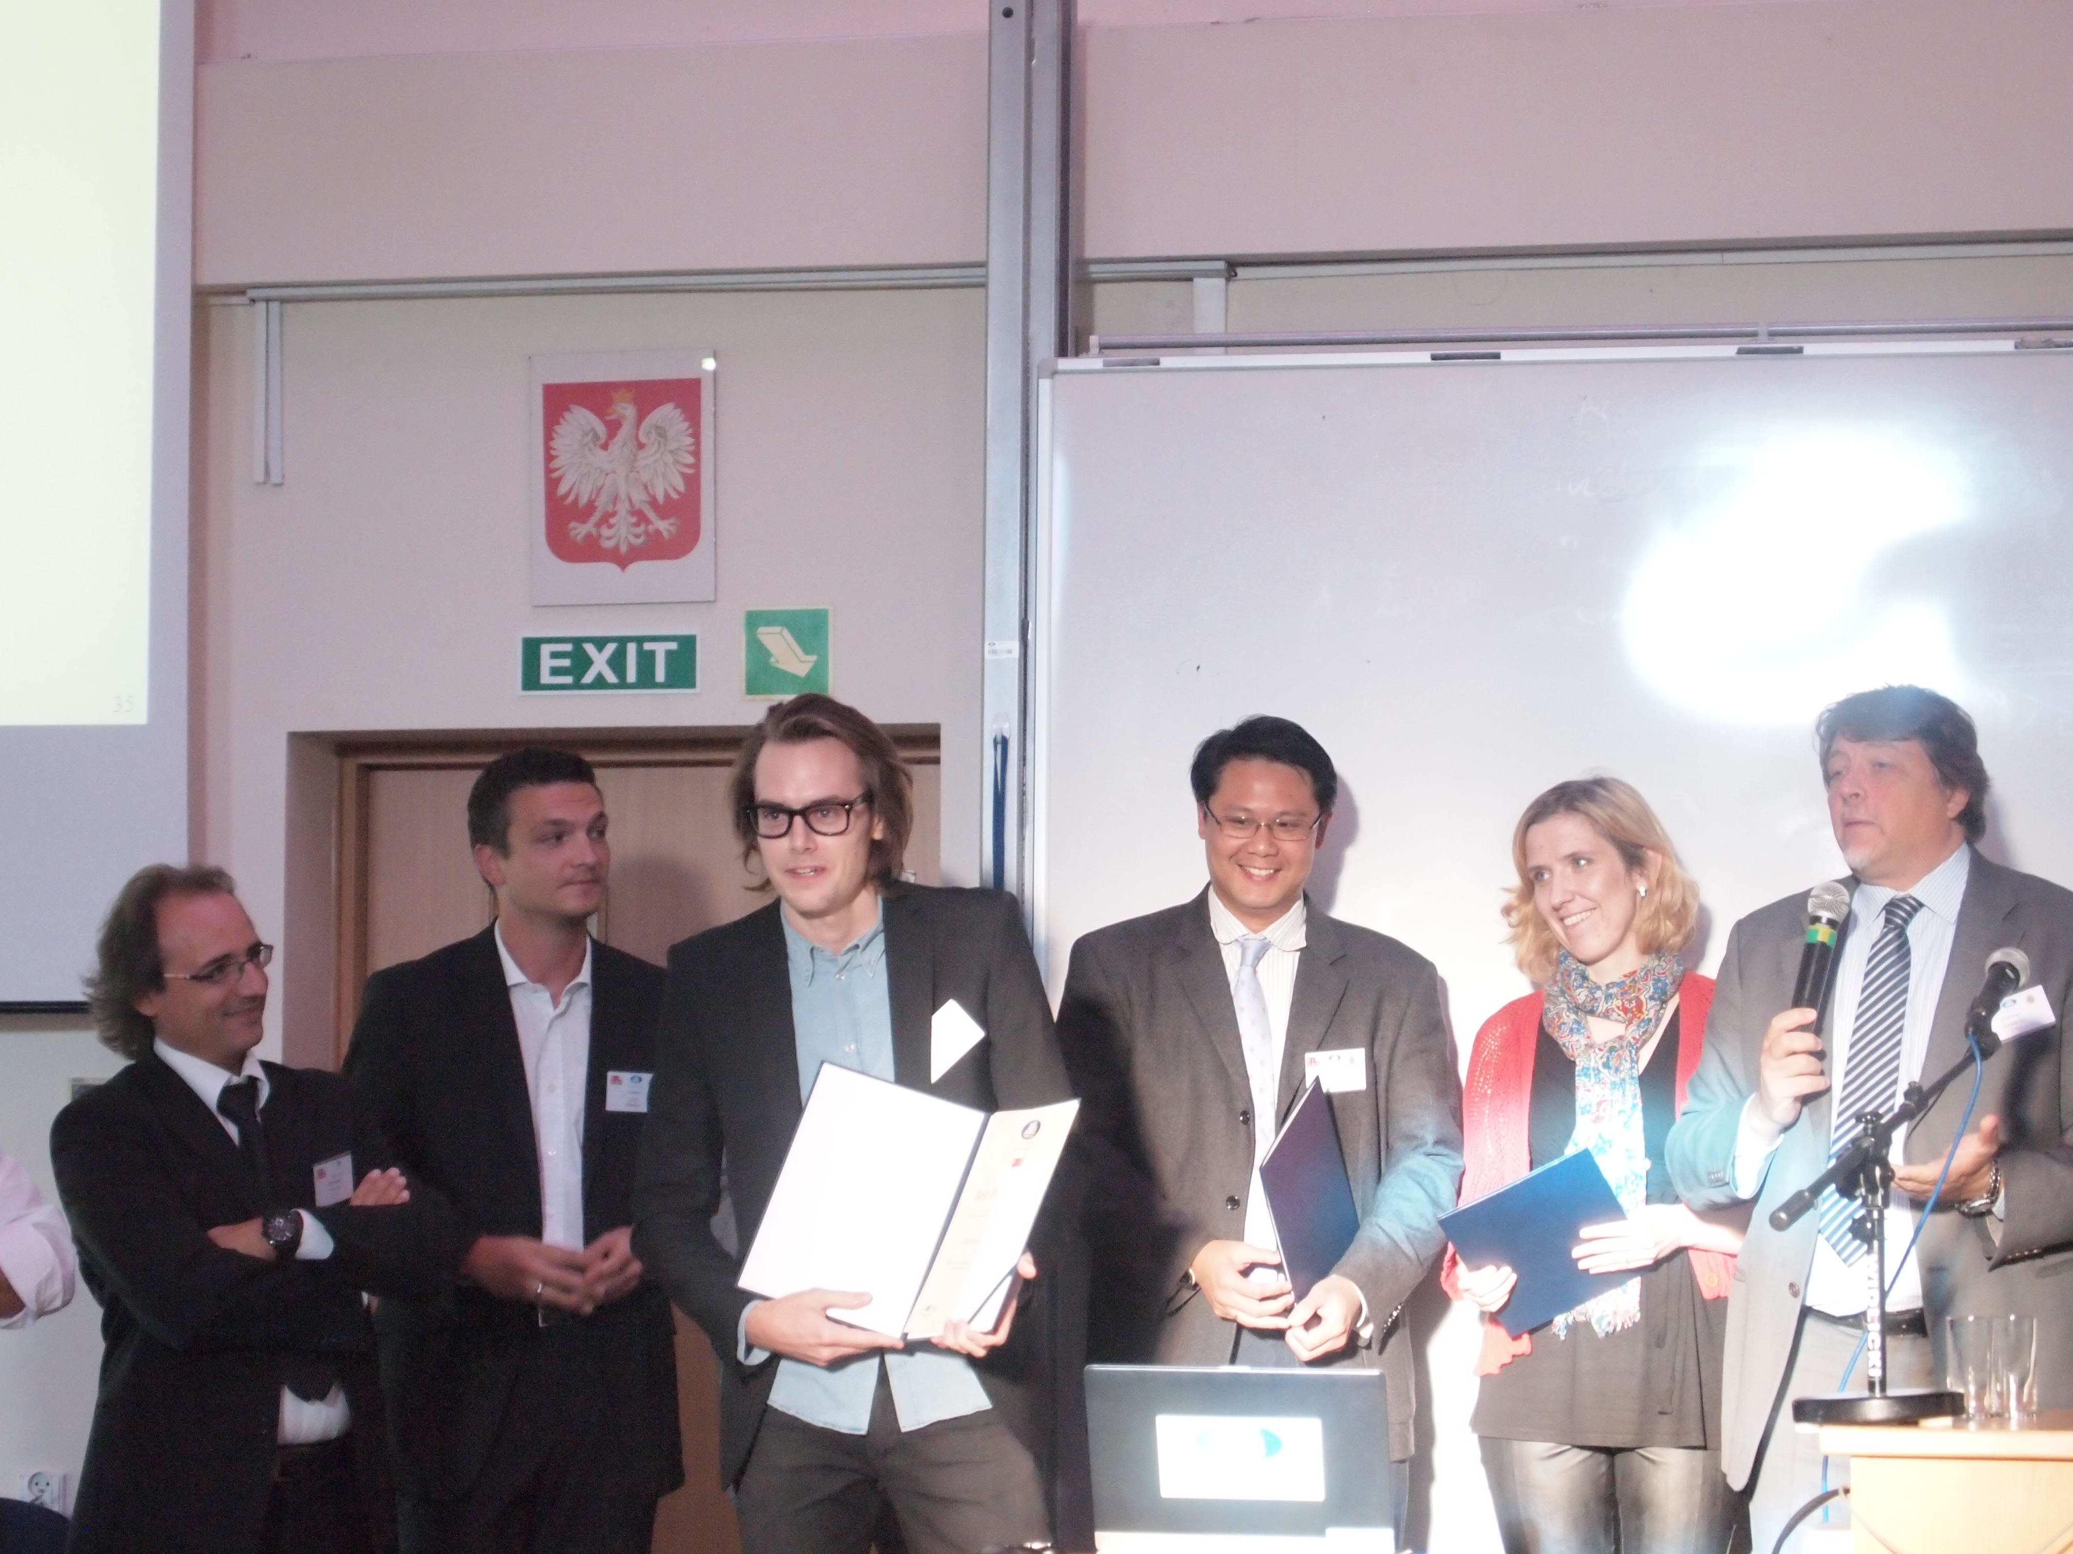
This year’s event in Warsaw has helped to promote the interest of academics and practitioners regarding the latest developments in the research on intangibles, intellectual capital and knowledge management. “I gathered a lot of understanding of what is going on and where the problems lie – especially from the business people on Friday”, said Prof. J.C. Spender (ESADE and University of Lund).

The Workshop was judged by all participants as a great and all-around success. The attempt to bring people from different disciplines to critically examine the concept and relevance of communities as spaces for learning, creativity and innovation, proved to be fruitful. The papers covered many dimensions of the topic, while the discussions were animated and perceptive, taking the workshop towards new ways of understanding spatial and organizational dynamics of learning and innovation. For example, according to Karol M. Klimczak (Kozmiski University), Chair of the parallel session on Management of Intangibles, “All the papers presented at this session are interdisciplinary and innovative”.

Next, the 8th Interdisciplinary Workshop on Intangibles, Intellectual Capital and Extra-Financial Information will be held 28-29 September 2012, at Grenoble Business School, France.

2nd EDEN SCHOOL ON VISUALISING, MEASURING & MANAGING INTANGIBLES AND INTELLECTUAL CAPITAL
Kozminski University, Warsaw, 26 September – 1 October 2011

Following the success of the 1st edition in 2010 in Catania, on 26 September to 1 October 2011, the 2nd edition of the EDEN Doctoral & Young Scholar School on Visualising, Measuring and Managing Intangibles and Intellectual Capital was held in Warsaw at Kozminski University.
(www.eiasm.org/frontoffice/eden_announcement.asp?event_id=809)

This EDEN course for doctoral students and young researchers deals with the multifaceted issues around conducting management research on intangibles and intellectual capital from a variety of theories, practices and methodologies. The structure of the School was organized according to an integrated set of diversified thematic seminars, which brought participants together into a systematic interaction, thus favouring a comparison of their approaches and a cross-fertilisation of their research work.

12 doctoral students and young researchers from all over Europe gathered to participate in a mix of intensive one-week seminars dealing with advanced research methodology issues in Management and Accounting. The seminars were presented by top professors in the various disciplines impinging on the intangibles field, including: accounting and financial reporting, managing knowledge assets for business performance improvements, corporate reputational capital, policy and economics implications and organization and strategy approach. The Faculty was composed of Prof. Baruch Lev (Stern, NYU), Prof. Manfred Schwaiger (LMU Munich), Prof. Marco Di Tommaso (University of Ferrara), Prof. Giovanni Schiuma (University of Basilicata), Prof. J.C. Spender (ESADE and Lund University), and Prof. Stefano Zambon (University of Ferrara, Coordinator) [see Photo 3]. The novelty this year was that the participants in the School presented their research projects using posters as a medium instead of the traditional PowerPoint slides.

Photo 3: Some of the participants in the EDEN School on Intangibles and IC
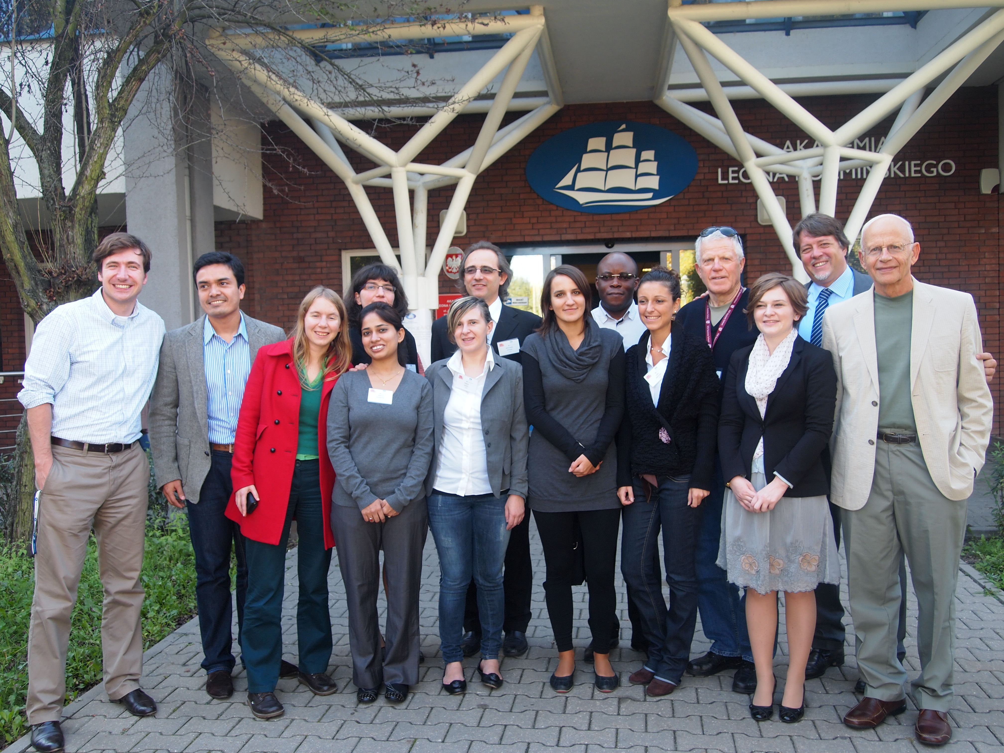
All participants agreed that this experience was a superb and exciting adventure. “It was an extraordinary experience for me. It changed the way I perceive things in my field of research, and it helped me connect with colleagues in the field with whom I might collaborate in the future”, said Andrea Bordianu, PhD Student, University of Leeds.

The 3rd edition of the EDEN Doctoral & Young Scholar School on Visualising, Measuring and Managing Intangibles and Intellectual Capital will be held at Grenoble Business School in France, 25-30 September 2012.

Paola Rossi
University of Ferrara

