Practical information:

How to reach the Palau Macaya?

From the Europark Hotel (8 min by walk)
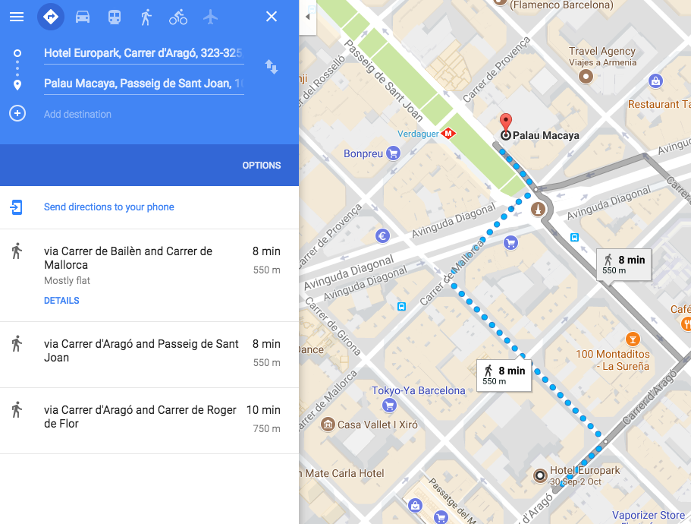

From the Ayre Hotel (15 min by walk)
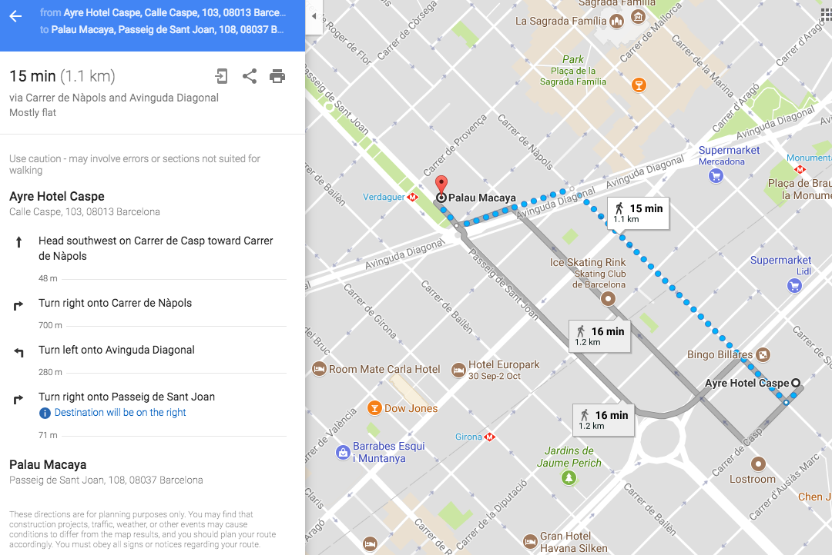
From the Room Mate Carla (7 min by walk)
