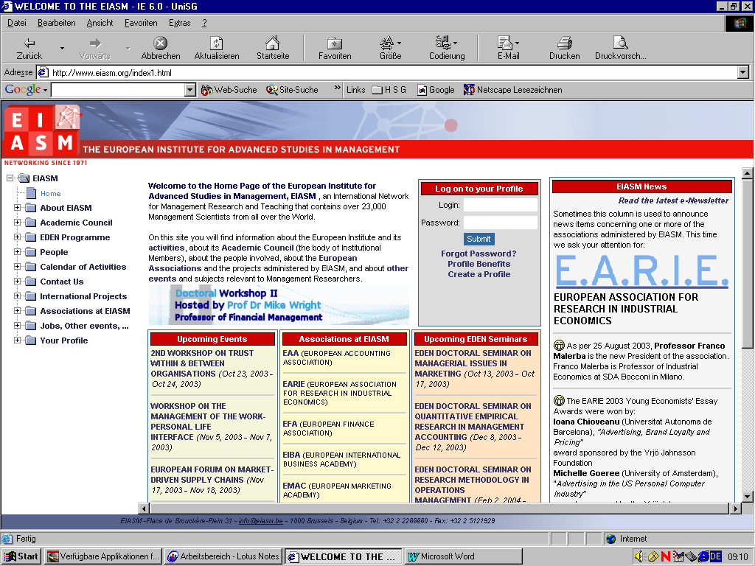
PLACE DE BROUCKÈRE-PLEIN - 31 - 1000 BRUSSELS - BELGIUM - Tel: 32 2 2266660 - Fax: 32 2 5121929

5th Workshop
on
Corporate Governance
Brussels, Belgium
November 27-28, 2008
PROGRAMME

Workshop – Day 1 – Thursday , November 27
Registration | 08:30 – 09:00
Introduction | 09:00 – 09:40
Parallel Sessions
TRACK A: International Corporate Governance  Chairperson : Martin Hilb |  | TRACK B: International Corporate Governance  Chairperson : Tomas Casas
THE EFFECTS OF STOCK OPTIONS ACCOUNTING REGULATION ON CORPORATE GOVERNANCE: A COMPARATIVE EUROPEAN STUDY  DI CARLO FERDINANDO, (NAPLES SECOND UNIVERSITY - ITALY) - OLIVIER BUTZBACH | 09:40 – 10:10 | A PRELIMINARY INVESTIGATION INTO AUSTRALIA’S REGISTERED CLUB INDUSTRY: ISSUES OF  CORPORATE GOVERNANCE AND GOVERNMENT REVIEW  MILLER PETER, (SOUTHERN CROSS UNIVERSITY - AUSTRALIA) - MICHAEL SINGLETON
PERFORMANCE EVALUATION OF DIFFERENT CORPORATE GOVERNANCE MODELS AND PRACTICES: THE  CASE OF THE UNITED KINGDOM AND PORTUGAL  FELÍCIO JOSÉ AUGUSTO, (ISEG SCHOOL OF ECONOMICS AND MANAGEMENT - PORTUGAL) - RICARDO RODRIGUES | 10:10 – 10:40 | EFFECTIVENESS OF CORPORATE GOVERNANCE OF CHINESE COMMERCIAL BANKS  FU MANLI, (ST. GALLEN UNIVERSITY - SWITZERLAND) -
DISCLOSURE OF THE REMUNERATION OF EXECUTIVE BOARD MEMBERS  FRANZONI SIMONA, (BRESCIA UNIVERSITY - ITALY) - | 10:40 - 11:10 | THE NATURE OF THE CORPORATE GOVERNANCE PROBLEM:  THEORY AND SOME EVIDENCE FROM INDIA  KHANNA SUSHIL, ( - INDIA) - PRADYOT K. SEN
Coffee Break | 11:10 – 11:30
IS THE NEW PARMALAT MODEL OF CORPORATE GOVERNANCE A BEST PRACTICE IN ITALY?  BAVA FABRIZIO, (TORINO UNIVERSITY - ITALY) - ALAIN DEVALLE | 11:30 – 12:00 | DOES STRATEGIC CORPORATE PERFORMANCE DEPEND ON CORPORATE FINANCIAL ARCHITECTURE?  EMPIRICAL STUDY OF EUROPEAN, RUSSIAN AND OTHER EMERGING MARKET’S FIRMS  IVASHKOVSKAYA IRINA, (HIGHER SCHOOL OF ECONOMICS - RUSSIA) - STEPANOVA ANASTASIA
THE ASSOCIATION BETWEEN BOARD AND ORGANIZATIONAL PERFORMANCE IN NONPROFIT AND  PUBLIC HEALTHCARE ORGANIZATIONS: A GREEK PERSPECTIVE  GEORGAKAKIS DIMITRIOS, (BRUNEL UNIVERSITY BUSINESS SCHOOL - U.K.) - DR DIMITRIOS KOUFOPOULOS | 12:00 – 12:30 | CORPORATE GOVERNANCE IN TRANSITION –OBSTACLES, PERSPECTIVES - CASE OF SERBIA  MARINKOVIC VLADIMIR
CORPORATE GOVERNANCE AND ROLE OF SHARIAH IN ISLAMIC BANKING  KHANDELWAL SUNIL, ( - UNITED ARAB EMIRATES) - | 12:30 – 13:00 | FROM 'ENTREPRENEURIAL STATE' TO 'STATE OF ENTREPRENEURS': OWNERSHIP IMPLICATIONS OF  THE TRANSFORMATION IN MEXICAN GOVERNANCE SINCE 19821  VARGAS JOSE, (INSTITUTO TECNOLOGICO DE CD GUZMAN - MEXICO) -
Lunch at the NH Hotel | 13:00 - 14:00
TRACK C : Strategic Direction  Chairperson : Hugh Grove |  | TRACK D : Strategic Direction  Chairperson : Laura Spira
MINORITY SHAREHOLDER PROTECTION RIGHTS AND THEIR RELATIVE INFLUENCE ON STRATEGIC  PLANNING.  MEAD LARRY | 14:00 – 14:30 | CORPORATE GOVERNANCE IN THE RETAIL INDUSTRY:  THE QUEST ON CORPORATE SOCIAL RESPONSIBILITY (CSR)  MENDONCA MARIA CRISTINA, (COIMBRA UNIVERSITY - PORTUGAL) -
MANAGEMENT AND INNOVATIONS - CORPORATE GOVERNANCE APPROACH  THEODOR MICHAL, (PRAGUE UNIVERSITY OF ECONOMICS - CZECH REPUBLIC) | 14:30 – 15:00 | SHAREHOLDER VERSUS STAKEHOLDER MODELS OF CORPORATE GOVERNANCE: SWEDEN'S MIDDLE  THORSELL ANNA, (UMEA UNIVERSITY / UMEA SCHOOL OF BUSINESS AND ECONOMICS - SWEDEN) -
CORPRATE GOVERNANCE AND CORPORATE SOCIAL RESPONSIBILITY: LESSONS FROM THE LAND OF  KEMP SHARON, (SWINBURNE UNIVERSITY OF TECHNOLOGY - AUSTRALIA) - | 15:00 – 15:30 | TOWARDS BETTER PRACTICES IN FAMILY BUSINESS GOVERNANCE: THE APPRECIATIVE INQUIRY  APPROACH  KOPONEN PIRJO, (JYVASKYLA UNIVERSITY - FINLAND) -
Coffee/Tea Break | 15:30 – 15:50
THE SUPERVISORY BOARDS OF POLISH PUBLIC COMPANIES AS SEEN BY THEIR FOREIGN MEMBERS  KOLADKIEWICZ IZABELA, (KOZMINSKI UNIVERSITY - POLAND) - | 15:50 – 16:20 | “THE NEED FOR MORE INDEPENDENT BOARDS  - IS IT RATIONAL OR NOT?  JOHANSON DANIEL, (NORWEGIAN SCHOOL OF ECONOMICS AND BUSINESS ADMINISTRATION - NORWAY) - KATARINA ØSTERGREN
THE CREDIT CRUNCH, INVESTOR ACTIVISTS AND CORPORATE STRATEGY: WILL THIS MEAN  SHAREHOLDERS IN THE BOARDROOM?  INGLEY CORAL, (AUCKLAND UNIVERSITY OF TECHNOLOGY - NEW ZEALAND) - JENS MUELLER, GRAEME COCKS | 16:20 – 16:50
Informal drink | 16:50 – 17:20
International Corporate Governance Research Workshop | 17:30- 19:30

Workshop

Track E : Board Management  Chairperson : Martin Hilb |  | Track F : “ Board Management  Chairperson : Tomas Casas
 | 08:30 – 09:00
BOARD EVALUATION - MEASURE OF EFFECTIVE CORPORATE GOVERNANCE?  RASMUSSEN JANICKE, (BI NORWEGIAN SCHOOL OF MANAGEMENT - NORWAY) - | 09:00 – 09:30 | MYOPIC ACTION AND MYOPIC INACTION - MYOPIA RELATED CONSTRUCTS IN A LISTED AND A  NON-LISTED COMPANY  CHAKHOVICH TERHI, (HELSINKI SCHOOL OF ECONOMICS - FINLAND) -
EXECUTIVE REMUNERATION: TOWARDS A STRUCTURED MULTI-THEORY APPROACH  BAETEN XAVIER, (VLERICK LEUVEN GHENT MANAGEMENT SCHOOL - BELGIUM) - | 09:30 – 10:00 | IMPACT OF BOARD EFFECTIVENESS ON INTERNATIONALIZATION OF BUSINESS GROUP AFFILIATES  SELEKLER-GOKSEN NISAN, (BOGAZICI UNIVERSITY - TURKEY) - Ã–ZLEM Ã–KTEM
Coffee Break | 10:00 – 10: 15 | Coffee Break
CORPORATE GOVERNANCE AND VOLUNTARY DISCLOSURE ACROSS LISTED SPANISH FIRMS  NAVALLAS BEGOÑA, (MADRID AUTONOMOUS UNIVERSITY - SPAIN) - ANA GISBERT CLEMENTE | 10:15 – 10:45 | ARE THEY WORTH THE MONEY THEY EARN? -  ROLE TAKING AND CONTRIBUTION OF GERMAN SUPERVISORY BOARDS  STEGER THOMAS, (CHEMNITZ TECHNICAL UNIVERSITY - GERMANY) - STEFFEN JAHN
NON-EXECUTIVE (OUTSIDE) DIRECTOR COMPENSATION: RATIONALE, FORM, AND FINDINGS  PETER HAHN | 10:45 – 11:15 | PAYING FOR ADVICE: THE ROLE OF THE REMUNERATION CONSULTANT IN UK LISTED COMPANIES  BENDER RUTH, (CRANFIELD UNIVERSITY / CRANFIELD SCHOOL OF MANAGEMENT - U.K.) -
DETERMINANTS OF NON-EXECUTIVE DIRECTOR REMUNERATION IN THE UK  PETER HAHN | 11:15 – 11:45 | COMPARATIVE ANALYSIS OF BOARD STRUCTURE IN NOT-FOR-PROFIT ORGANISATIONS  MALY MILAN, (PRAGUE UNIVERSITY OF ECONOMICS - CZECH REPUBLIC) -
Lunch at the NH Hotel | 11:45 – 13:15
TRACK G : Strategic Control  Chairperson : Hugh Grove |  | TRACK H : Strategic Control  Chairperson : Laura Spira
STRATEGIC ORIENTATION AND CORPORATE GOVERNANCE: THE CONTEXTUAL ROLE OF OWNERSHIP  DI TOMA PAOLO, (UNIVERSITY OF MODENA E REGGIO EMILIA - ITALY) - | 13:15 – 13:45 | CORPORATE GOVERNANCE IN TRANSITION: UK WITH-PROFITS FUNDS AND THE UK FINANCIAL  SERVICES AUTHORITY  RUSSELL PETER, (EAST ANGLIA UNIVERSITY NORWICH - U.K.) - IAN DEWING
GOVERNANCE AND OWNERSHIP: PRACTICES IN ESTONIA  WAHL MIKE FRANZ, (TALLINN TECHNICAL UNIVERSITY - ESTONIA) - | 13:45 – 14:15 | CORPORATE GOVERNANCE LISTING REQUIREMENTS: INVESTOR PROTECTION FROM FRAUDULENT  FINANCIAL REPORTING.  VICTORAVICH LISA, (DENVER UNIVERSITY - U.S.A.) - HUGH GROVE, KHALED ALJIFRI AND LISA  VICTORAVICH
AUDITORS' RELUCTANCE TO ISSUE RED FLAGS: AN EXPERIMENT  GUIRAL ANDRES, (ALCALA UNIVERSITY - SPAIN) - WAYMOND RODGERS  EMILIANO RUIZ  JOSE A. GONZALO | 14:15 – 14:45 | THE LEAKY BUCKET PRINCIPLE OF COMMUNITY DEVELOPMENT IN GLOBAL AND INTERNATIONAL  PARTNERSHIPS  VARGAS JOSE, (INSTITUTO TECNOLOGICO DE CD GUZMAN - MEXICO) -
Coffee/Tea Break | 14:45 – 15:00
CORPORATE GOVERNANCE REGULATIONS AND BEST PRACTICES IMPACT ON INTERNAL AUDIT IN  KOUTOUPIS ANDREAS, ( - GREECE) - | 15:00 – 15:30 | IMPROVING CORPORATE GOVERNANCE THROUGH A BALANCED RISK MANAGEMENT APPROACH  PEROZZI DOMENICO, (PESCARA "G.D'ANNUNZIO" DI CHIETI-PESCARA UNIVERSITY - ITALY) - LORENZO  LUCIANETTI
BOARD INDEPENDENCE AND EARNINGS CONSERVATISM:  EVIDENCE FROM BANK ORIENTED FINANCIAL SYSTEM  KANKAANPÄÄ JARI, (TAMPERE UNIVERSITY - FINLAND) - | 15:30 – 16:00 | INTER-ORGANIZATIONAL GOVERNANCE,  QUALITATIVE EVIDENCE FROM THE BUSINESS AVIATION SUPPLY CHAIN.  IZZO FILOMENA, (NAPLES SECOND UNIVERSITY - ITALY) - MUSTILLI MARIO
BOARD COMPETENCY EXPLANATIONS FOR DIFFERENTIATION IN A HARMONISATION ENVIRONMENT  HOLM CLAUS, (AARHUS SCHOOL OF BUSINESS - DENMARK) - FINN SCHOELER | 16:00 – 16:30 | A PRELIMINARY INVESTIGATION INTO AUSTRALIA’S REGISTERED CLUB INDUSTRY: ISSUES OF  CORPORATE GOVERNANCE AND GOVERNMENT REVIEW  MILLER PETER, (SOUTHERN CROSS UNIVERSITY - AUSTRALIA) - MICHAEL SINGLETON
Conclusions and lessons learned | 16:30 -

